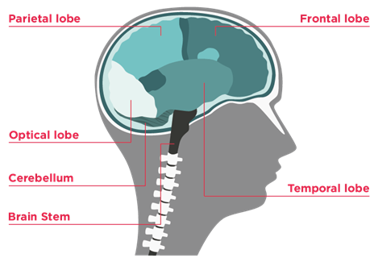
I have, or had, a brain tumour here:
(draw where the tumour is, if known)

My type of brain tumour is called/
I call it:
(include grade, if known)

It is OK to ask me about this ☐

Please don’t ask me about this ☐
(I find it tricky to talk about)

My friends who know about this are:

I come to school on these days/at these times:

I need to take medicines at these times:

(and who can give them to me, if I can’t take them myself)

I need help with:

(please also see my Educational Support Strategy – quick reference sheet)

I am good at:

It is ordinary for me to:
(e.g. put my head down for a rest, go to the toilet often, eat/drink during lessons)

You will know if I am becoming unwell and need help, if:
(what to look out for, when to contact school nurse/responsible staff member or follow school’s medical emergency procedure)

My key worker’s name is:

This card should be filled in by the young person (and/or their parent) and kept on the young person to show the relevant teacher(s), or kept by the teacher.
Fold along the grey lines so it can fit into a wallet, pocket or purse.

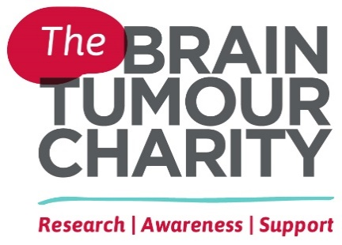
If found, please give to a teacher
or hand in to the school office

Information card

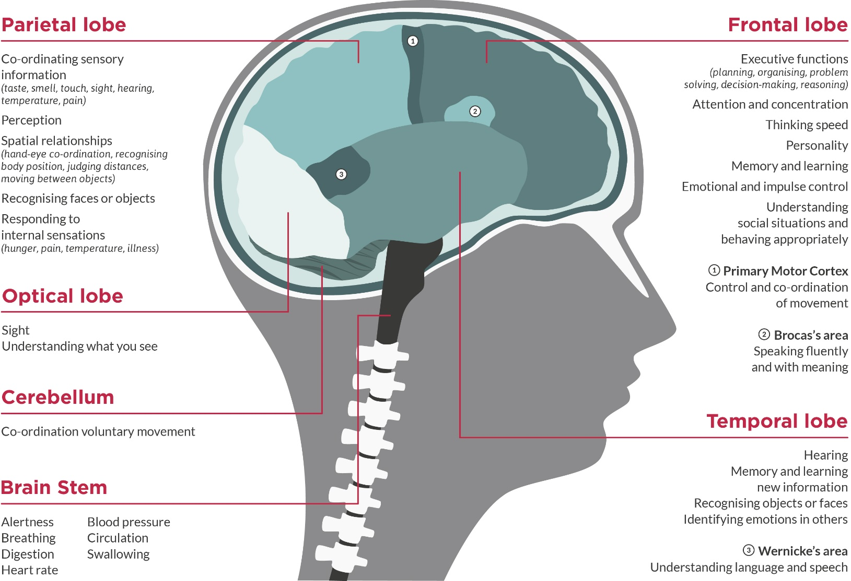

For information about
brain tumours:

The Brain Tumour Charity
thebraintumourcharity.org
0808 800 0004 or support@thebraintumourcharity.org

