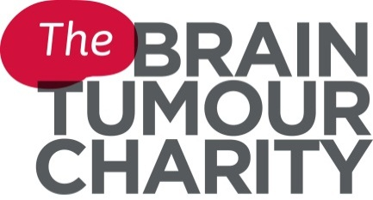
Press Release

XX / 10 / 2017

With pic
(write this here if you are attaching one)

Description of you (eg student, policeman, teacher, grandfather) joins charity walk to help beat brain tumours
subhead

On date of walk, Firstname Surname from your home town or village (eg John Smith from Ascot) will join dozens of others affected by brain tumours on The Twilight Walk through Windsor/Warwick/Chester/York.
Firstname was inspired to take part after why you are joining The Twilight Walk – eg losing her father to a brain tumour three years ago.
The ten-kilometre walk begins at dusk and is aimed at bringing together patients and families affected by brain tumours, as well as raising money to help fight the disease.
For Windsor: The route takes in historic sights including the Long Walk and Windsor Castle.
For Chester: The route takes in sights including the city walls and the Queen’s Park suspension bridge.
For Warwick: The route takes in historic sights including the castle and the River Avon.
Firstname said: “The Twilight Walk will be a fantastic opportunity to meet up with other people whose lives have been touched by brain tumours, to show our solidarity and support for each other and to raise money for the brain tumour research that we all know is so badly needed.
Add in any other comments here about your personal reasons for doing the walk and your commitment to The Brain Tumour Charity – eg “My mum loved walking and Chester was one of her favourite places so it seemed like the perfect way to do something positive in her memory”.
Geraldine Pipping, The Charity’s Head of Fundraising, said: ““The Twilight Walk helps to show people affected by brain tumours that they are not alone.
“Brain tumours are the biggest cancer killer of children and the under-40s in the UK and survival rates have not improved significantly over the last 40 years.
“We are leading the way in changing this and recently published our ambitious five-year strategy, Defeating Brain Tumours, which aims to double survival and halve the harm caused by brain tumours.
“We receive no government funding and rely 100% on voluntary donations, so it’s only through the efforts of people like Firstname that we can change these shocking statistics in the future and bring hope to the thousands of people who are diagnosed with a brain tumour every year.”
There is no upper or lower age limit for participants in The Twilight Walk. For more information and to register for the walk, go to https://www.thebraintumourcharity.org/get-involved/thetwilightwalk/

Ends
Photo: if you are attaching a photo include a short description, the full names of anyone in it and their position in the picture.
For further information, pictures and media enquiries please contact:
insert your name, email address and contact phone number(s).

Notes to editors

About The Brain Tumour Charity
Registered Charity No. 1150054 (England and Wales) SC045081 (Scotland)
The Brain Tumour Charity is at the forefront of the fight to defeat brain tumours, making a difference every day to the lives of people with a brain tumour and their families. It funds pioneering research to increase survival, raises awareness of the symptoms and effects of brain tumours and provides support for everyone affected.
The Charity’s goals are to double survival within 10 years in the UK and to halve the negative impact that brain tumours have on quality of life.
It adheres to nationally-recognised accreditations and best practice guidelines for every area of its work.
The Charity funds an extensive and diverse portfolio of research across the UK with the aim of doubling survival and reducing long term harm through improving the understanding and complexities of brain tumours, better diagnostic techniques and new treatments.
The Brain Tumour Charity offers a comprehensive support and information service for anyone who is affected, including a support and information line, Information Standard accredited fact sheets, online peer-to-peer support and a dedicated Children and Families Service.
It funds and promotes the UK-wide HeadSmart campaign, raising awareness of the signs and symptoms of brain tumours in children and young people to make earlier diagnosis a reality. Earlier diagnosis will reduce long-term disabilities and save lives.
In just three years, HeadSmart has reduced averaged diagnosis time from 9.1 weeks to 6.5 weeks.
Find out more at: www.thebraintumourcharity.org
Members of the Association of Medical Research Charities, The Information Standard, The Helplines Partnership and the Fundraising Standards Board.
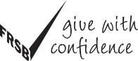
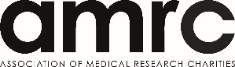

  - Brain tumours – the facts
- Brain tumours are the biggest cancer killer of children and adults under 40.
- Almost 11,000 people are diagnosed each year with a primary brain tumour, including 500 children and young people – that’s 30 people every day.
- Over 5,000 people lose their lives to a brain tumour each year.
- Brain tumours reduce life expectancy by on average 20 years – the highest of any cancer.
- Just 19% of adults survive for five years after diagnosis.
- Brain tumours are the largest cause of preventable or treatable blindness in children. Childhood brain tumour survivors are 10 times more likely to suffer long term disability than well children. This accounts for 20,000 additional disabled life years for all the children who are diagnosed each year.
- Research offers the only real hope of dramatic improvements in the management and treatment of brain tumours. Over £500m is spent on cancer research in the UK every year, yet less than 2% is spent on brain tumours.

