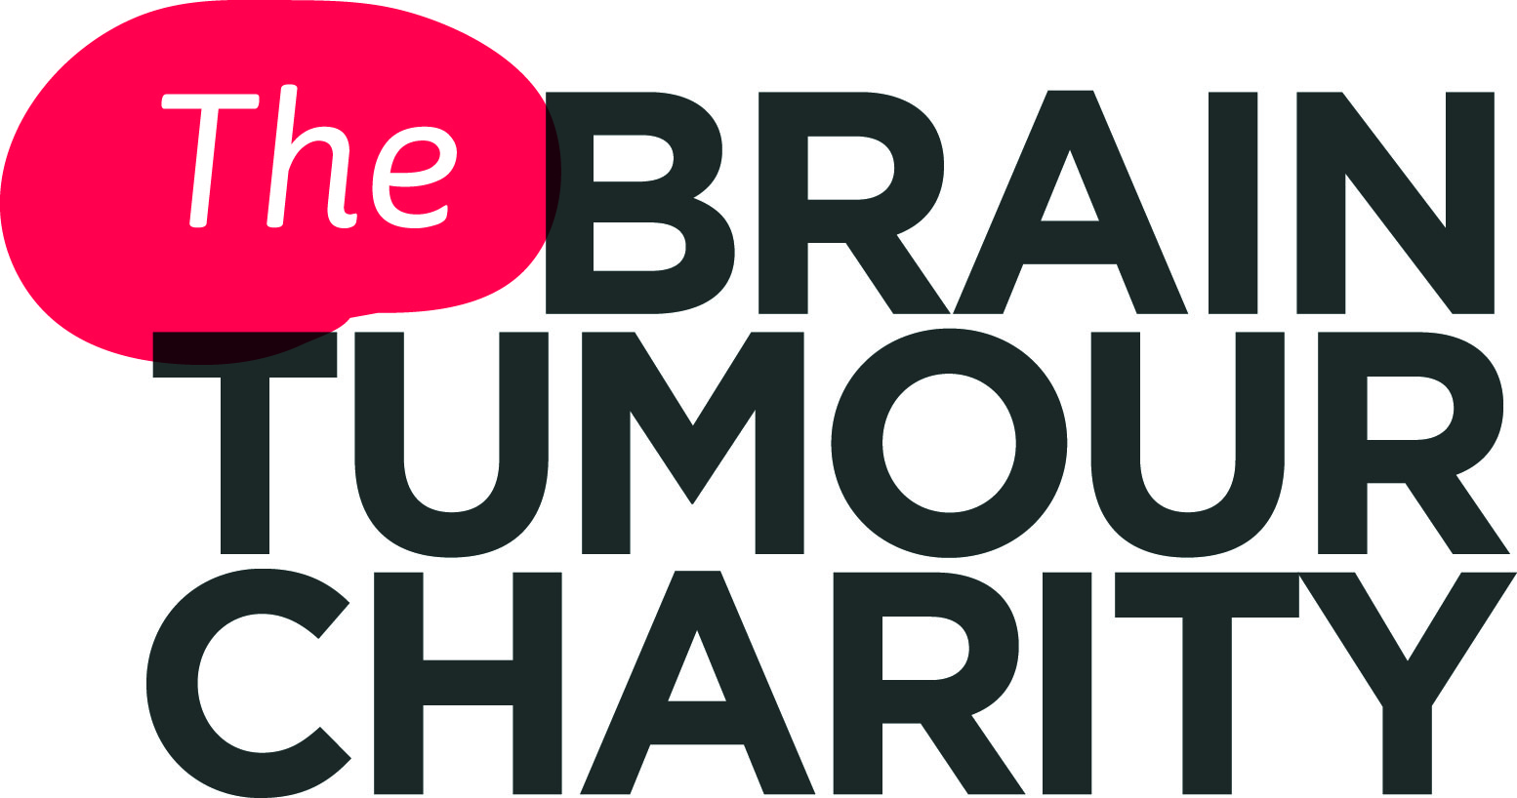

Driving and brain tumours
If you have been diagnosed with a brain tumour, you are required by law to inform the DVLA (Driver & Vehicle Licensing Agency) or, in Northern Ireland, the DVA (Driver & Vehicle Agency).
It is very common to be asked to give up your driving licence. This may be temporary, but some people unfortunately will not be able to drive legally again. This will depend on your type of tumour and the treatment you have.
There are a variety of services and practical schemes that may help overcome the loss of independence that some people feel.
In this fact sheet:
- Informing the DVLA or DVA
- How long will I be unable to drive?
- How do I get my licence back?
- Questions if I get my licence back
- Having a car adapted
- What if I don’t get my licence back?

Please note that this information is relevant to people holding a group 1 licence (for cars and motorcycles). Rules relating to group 2 licences (large lorries and buses) differ. You can find out more about group 2 licences from the DVLA or DVA - their contact details are given in this fact sheet.

Informing the DVLA or DVA
It is a legal requirement to inform the DVLA as soon as possible if you have been diagnosed with a brain tumour. In Northern Ireland you must tell the DVA.
If you are allowed to continue to drive, or when/if you get your licence back, you must also tell them if your condition worsens and about any medication or treatments you are having that could affect your driving.
You can be fined up to £1000 if you do not tell the DVLA/DVA, and you may be prosecuted if you are involved in an accident as a result of your tumour affecting your ability to drive.
When you contact the DVLA/DVA, it is a good idea to voluntarily surrender (give up) your licence and send it to them at the same time. If you do not, they could revoke (take away) your licence, which may feel more distressing.
In addition, having your licence revoked can make the process of getting your licence back more complicated. Gaining permission from the DVLA/DVA to drive again takes longer and is more difficult if your licence has been revoked rather than voluntarily surrendered.
To inform the DVLA (England, Wales, Scotland) about your diagnosis of a brain tumour, you will need to fill in a Form B1. This is available online at: gov.uk/government/publications/b1-online-confidential-medical-information or you can contact the DVLA for a paper copy.
(Please see contact information below).

When you inform the DVLA about your diagnosis, using Form B1, you will be asked to include the following information:
- Your full name, date of birth and driver’s number
- Name and contact details of your GP and consultant
- Type and grade of tumour and date of your diagnosis
- Any treatment you have had, plus dates, and any planned or possible further treatments

For further information, contact:

DVLA Drivers Medical Enquiries (England, Wales, Scotland)
Tel: 0300 790 6806 (medical enquiries and appeals)
Monday to Friday 08:00 -17:30
Saturday 08:00 - 13:00
Email: please see links on the following web page:
gov.uk/contact-the-dvla
Post: Drivers Medical Group, DVLA, Swansea SA99 1TU
Web: gov.uk/dvla-medical-enquiries
gov.uk/driving-medical-conditions
gov.uk/brain-tumour-and-driving

To inform the DVA (Northern Ireland), you must send both parts of your licence, along with a covering letter giving details of your condition, to:

DVA Drivers Medical Section (Northern Ireland)
Tel: 0300 200 7861 (medical enquiries and appeals)
Monday to Friday 09:00 -17:00
Saturday 08:00 - 13:00
Email: dva@doeni.gov.uk
Post: Drivers Medical Section, DVA, Castlerock Road, Waterside, Coleraine BT51 3TB
Web: nidirect.gov.uk/index/information-and-services/motoring/driver-licensing/telling-dva-about-a-condition.htm
They will then send you the appropriate medical questionnaire to gain more details about your condition. It also includes a section for you to give permission for the DVA to contact your doctor(s), if required.
How long will I be unable to drive?
The length of time that you will be unable to drive depends on:
- Type of your brain tumour
- Grade of your brain tumour
- Where the tumour is within your brain
- Type of treatment you have received and when it was completed
(Brain tumours are graded from 1- 4 according to their behaviour, such as the speed at which they grow and how likely they are to spread. Grades 1 and 2 are low-grade, slow-growing and sometimes referred to as benign. Grades 3 and 4 are high-grade, fast-growing and often referred to as malignant or cancerous. (For more information, see our ‘What is a brain tumour?’ fact sheet).
For many types of high grade tumour, you will not be allowed to drive for at least two years, while for lower grade tumours, it may be one year, but it can be less. These time spans are from completion of treatment, which can include radiotherapy and chemotherapy.

For example, with pituitary tumours, low grade tumours in the cerebellum or brain stem, and grade 1 meningiomas, you can generally drive once you have recovered from treatment. This is as long as you have NOT had treatment via a craniotomy (where part of the skull is removed to allow access to the brain). In this case you cannot drive for six months.
In all these cases, there must be no other factors or after-effects of treatment that could affect your ability to drive, before you are allowed to drive again.

Other factors that may affect how long I am unable to drive
Depending on the type, grade and location of your tumour, you may also have other factors that can affect whether you are allowed to drive, on top of your diagnosis with a brain tumour.
Two of the key factors are:
- Epileptic seizures
Epilepsy is a common symptom of all brain tumours, particularly low grade tumours. Around 60% of people with a brain tumour will experience a seizure at least once. (For more information, see our ‘Epilepsy (seizures) & brain tumours’ fact sheet.)
If you have had a seizure of any type, you will not be allowed to drive. This is the case whether your consciousness has been affected or not. The period when you are not allowed to drive will usually be for at least one year from your last seizure - though for some low grade, ‘benign’ tumours it may be less, and for other higher grade tumours, it is likely
to be more.
For more information, please see:
gov.uk/current-medical-guidelines-dvla-guidance-for-professionals-neurological-chapter-appendix
- Visual disturbances
Some brain tumours bring about visual disturbances, such as hallucinations or seeing flashing lights. Others, such as pituitary tumours, can cause reduced peripheral vision (side vision) i.e. problems with seeing things to the sides of the object you are looking directly at. Driving could put you and others at serious risk.
For more information, please see:
gov.uk/current-medical-guidelines-dvla-guidance-for-professionals-vision-chapter-appendix
Though it is hard to hear, it may be that the combination of these factors
and/or your diagnosis with a brain tumour, means you will not be able to legally drive again.

What if I had a brain tumour as a child?
If you had a brain tumour as a child, with no recurrence, and do not have other factors as a result of your tumour, such as epilepsy or visual disturbances, you can have/keep a regular driving licence until the usual age of 70.
Summary
It is important to remember that this is a general guide - everyone’s tumour is different and the DVLA will consider your individual situation and risk of further symptoms before allowing you to drive again.
A good source of information about how long you are likely to be unable to drive: At a glance guide to the current medical standards of fitness to drive (for medical practitioners).
This can be found on the gov.uk website:
gov.uk/government/publications/at-a-glance

How do I get my licence back?
The DVLA will have sent you a letter when your licence was taken away or surrendered, which will have told you if there was a period of time you needed to wait before getting a new licence.
Licence voluntarily surrendered (given up)
If you surrendered your licence, you can apply to have it back eight weeks before the end of the period for which you have been disqualified to drive, as long as your doctor has told you that you are fit to drive.
To reapply for your licence, you will need to fill in a D1 application form plus the form for your medical condition i.e. brain tumour (Form B1).
The D1 form and additional information you need to make an application (the D1 Pack) can be ordered online via the gov.uk website: gov.uk/dvlaforms. The packs are also available from the Post Office. The B1 form for your medical condition can be found on the gov.uk website: gov.uk/health-conditions-and-driving
You need to check with your doctor that you are fit to drive before applying to get your licence back. You may need to send evidence of your fitness to drive. The letter you received from the DVLA, when your licence was taken away or surrendered, will tell you if this is the case. The DVLA/DVA will always check the information with your doctor. If you do not need to send evidence, the DVLA/DVA will check directly with your doctor that you are fit to drive.
Licence revoked (taken away)
If your licence was revoked, the same application process applies, but you cannot start driving until the DVLA decides if you are medically fit to drive. The DVLA will speak to your medical specialists about your individual circumstances to make a decision about your driving licence. This can be a long and very time-consuming process.
Questions if I get my licence back
Will I get a full licence back?
When you get your driving licence back, it may be ‘medically restricted’. This means that because of a medical condition, it is restricted, so that it lasts usually one, two or three years. Three years is the most common.
At the end of this time period you need to check with your doctor that you continue to be fit to drive, and apply for your licence to be renewed, via the process described above in the How do I get my licence back? section of this fact sheet. These medically restricted licences are still counted as a ‘full
UK licence’.
Having a medically restricted licence does not necessarily mean you can drive legally for the length that licence covers. If your tumour regrows, or you experience new or recurrent symptoms, such as a seizure, you must tell the DVLA and your licence may need to be surrendered or revoked again.
You must also tell the DVLA about any changes in your medicines or treatments that could affect your driving.

Will I have to retake my driving test?
Whether your licence was surrendered or revoked, you do not have to take your driving test again, once your licence is returned to you.

Will the cost of my car insurance increase?
The AA advises that you have a ‘duty of disclosure’ to your insurer and you should therefore tell your insurers about your diagnosis as soon as possible to avoid problems with any future claims.
Your insurance company can ask for more information about your medical condition to support your application for insurance. They may also ask for evidence that you are allowed to drive, such as your driving licence or a letter from the DVLA confirming that you are permitted to drive.
Under the Equality Act 2010, they cannot increase the cost of your policy if your medical condition does not affect the risk of making a claim.
Also if you have a time-restricted licence (i.e. one that is valid for a few years), your insurers cannot use this as a reason to put your premiums up or refuse to cover you.
If your insurers do increase your premium, they have to tell you why. For example, they may temporarily put up your premium or increase the excess while you are ‘getting used to a new disability or condition’, but they can only do this if there is evidence that you are an increased risk during this period.
They also have the right to charge more if it will cost them more to provide a service. For example, if you have your car adapted to enable you to continue to drive, a temporary increase in the premium may be charged while you learn to drive the new car. Or, an increase may be more permanent to offset the increased costs of any potential repairs.
It is worth contacting several insurance companies to get the best quotes for your car insurance.

Having a car adapted
Depending on the nature of the problems that your brain tumour has caused,
it may be possible to have your car adapted so that you are still able to drive. Adaptations can include hand controls instead of foot controls, left-foot accelerators, adapted mirrors and wheelchair hoists.
There is special VAT relief for adapted vehicles bought or leased, such as
under the motability scheme (see below).
The following websites have good information about choosing an adapted car
or having your car adapted.
RICA (Research Institute for Consumer Affairs)
A UK consumer research charity, which provides practical information based
on independent research and the experiences of consumers and experts.
rica.org.uk/content/mobility
rica.org.uk/content/motoring-after-brain-injury
Forum of Mobility Centres
A network of independent organisations covering the UK, who offer professional advice to people who have a medical condition or are recovering from an accident which may affect their ability to use a motor vehicle.
mobility-centres.org.uk/
Motability
A national UK charity, which helps people with disabilities and their families
to become mobile.
If you receive the Higher Rate Mobility Component of Disability Living Allowance (HRMC DLA) or the Enhanced Rate of the Mobility Component of Personal Independence Payment (ERMC PIP), you may be able to use the Motability scheme to lease an adapted vehicle.
motability.co.uk/
Other help
Blue Badge Scheme
The Blue Badge Scheme, which operates throughout the UK, is a scheme which allows eligible people to park closer to where they need to go. The badge is also recognised in some European countries.
In England, Wales and Scotland it is operated by your local authority; in N. Ireland it is administered by TransportNI. Contact the relevant organisation for an application form, or you can apply online.
What if I don’t get my licence back?
For many people, driving is one of their most valued activities. Whether someone is able to drive or not can impact all areas of life including employment, how to pick up the children or get groceries, leisure activities, getting to a doctor’s appointment and even where you live.

Not being able to drive is one of the things that people diagnosed with a brain tumour often report as one of the most difficult to deal with in terms of changes to their daily life. Loss of a licence is often seen as loss of independence.
Emotional help
It can be helpful to know that this is a common way to feel. Talk to your Clinical Nurse Specialist - they can provide psychological and emotional, as well as practical, support.
Find other people you can talk to about how they have dealt with it e.g. via a support group or an online community, such as those provided by The Brain Tumour Charity.

The Brain Tumour Charity has an active Facebook support group that you can access anywhere in the world and at any time, where you can ‘meet’ others (brain tumour patients and carers) and discuss your worries, fears and share ideas. Or, if you are not ready to speak to others directly, you can simply read about the experiences of others.

bit.ly/supportonfacebook

Practical help
Being driven by a carer
If you surrender your licence or don't get it back, you may find that your main carer becomes your driver. You can still apply for the Blue Badge Scheme (see ‘Other help’ section of this fact sheet) even if you are not driving, and your carer can use it when they take you out. You can also use the badge in other cars
or taxis you are using them.
People affected by brain tumours in this situation have said that, after discussion with your ‘carer driver’ and, if it is possible, it can be helpful to change your
car for one with more doors and more room for carrying equipment, such as
a wheelchair.

Access to Work grants
If are in (or about to start) paid work or self-employment, you are 16 or over, and your brain tumour means you are unable to use public transport, you may be able to apply for an Access to Work / Access to Work (NI) grant to pay for taxi fares to work.
Funding can cover up to three years, but you are normally reviewed every year to see if you still need the finding.
You might not qualify if you are claiming certain benefits, such as Incapacity Benefit, Employment and Support Allowance,
Severe Disablement Allowance, Income Support, National Insurance Credits.
To see if, and how, you can apply, contact Access to Work at:
England, Scotland & Wales
atwosu.london@dwp.gsi.gov.uk
Telephone: 0345 268 8489
Textphone: 0345 608 8753
Northern Ireland
Via an Employment Service Adviser in your local Jobs & Benefits office or JobCentre.
Concessionary public transport
If you have had your licence revoked on medical grounds, such as a brain tumour, you may be entitled to free or concessionary public transport fares.
For information about what you are entitled to and how to apply for a pass, please see the following websites:
England and Wales
gov.uk/apply-for-disabled-bus-pass
This link enables you to find your local council website, where you can find out who issues disabled bus and other public transport passes in your area.
Scotland
transportscotland.gov.uk/public-transport/concessionary-travel-people-aged-60-or-disability
Northern Ireland
nidirect.gov.uk/free-bus-travel-and-concessions

Community transport
Many areas also have community transport services for people who have difficulty using public transport, either through disability issues or because they live in a rural area with limited or no public transport services. These include door-to-door transport and trips to shopping centres.

England and Wales

gov.uk/community-transport-services-shopmobility

Scotland

transportscotland.gov.uk/public-transport/concessionary-travel/accessible-travel-information-and-links#Comm

Northern Ireland

nidirect.gov.uk/community-transport-and-shopmobility

Charities

Across the UK there are a variety of charities that can also
help with transport. For example, the British Red Cross offers transport support for medical appointments and essential daily needs.

Contact our Support & Info Line - we can look up the help that is available in your local area.

Appeals procedure

If the DVLA/DVA decides not to give your licence back and you don’t agree, you can ask them to review your case. You will need to send a letter along with
a supporting letter from your GP. If you also have some medical evidence that was not previously available to the DVLA/DVA, you will need to send this also.
If your request for a review is not successful, you can make a formal appeal. The DVLA/DVA should have sent you details of the appeals process when they informed you of their decision not to give your licence back.
It is important to remember that if you do not meet the driving rules for people with a brain tumour (and/or, where relevant, the epilepsy or visual impairment rules), the DVLA/DVA cannot legally re-issue your licence.

If you decide to appeal:
- Before you appeal, you must let the DVLA/DVA know you are going to appeal
- It is advisable to get legal advice first
- If you don’t win, you have to pay the DVLA’s costs
- There is a time limit on when you can appeal
(from the date of the DVLA’s decision)
England & Wales - 6 months
Scotland - 21 days
N. Ireland - 3 months

If you live in England or Wales, you need to appeal to your local magistrate’s court; if you live in Scotland, to the Sheriff’s Court; and in N. Ireland, to the
Clark of Petty Sessions in the area where you live, plus a copy of the Notice
to Appeal to the Departmental Solicitors Office in Belfast at least 14 days before the hearing.

What if I have further questions?
If you require further information, any clarification of information, or wish to discuss any concerns, please contact our Support and Information Team:
- Call: 0808 800 0004
(Free from landlines and most mobiles:
3, O2, EE, Virgin and Vodafone)
- Email: support@thebraintumourcharity.org
- Join our closed Facebook groups:
bit.ly/facebooksupportgroup
bit.ly/carersupportgroup

About us
The Brain Tumour Charity makes every effort to ensure that we provide accurate, up-to-date and unbiased facts about brain tumours. We hope that these will add to the medical advice you have already been given. Please do continue to talk to your health team if you are worried about any medical issues.
The Brain Tumour Charity is at the forefront of the fight to defeat brain tumours and is the only national charity making a difference every day to the lives of people with a brain tumour and their families. We fund pioneering research
to increase survival, raise awareness of the symptoms and effects of brain tumours and provide support for everyone affected to improve quality of life.
We rely 100% on charitable donations to fund our vital work. If you would like to make a donation, or want to find out about other ways to support us including fundraising, leaving a gift in your will or giving in memory, please visit us at thebraintumourcharity.org, call us on 01252 749990 or email fundraising@thebraintumourcharity.org

About this fact sheet
This fact sheet has been written and edited by The Brain Tumour Charity's Support and Information Team. The accuracy of information has been verified by a leading experts in the field. Our fact sheets have been produced with the assistance of patient and carer representatives and up-to-date, reliable sources of evidence. If you would like a list of references for any of the fact sheets, or would like more information about how we produce them, please contact us.

Driving

Your notes

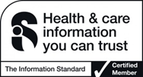
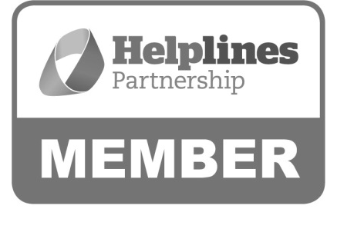

Hartshead House
61-65 Victoria Road
Farnborough
Hampshire
GU14 7PA
01252 749990
enquiries@thebraintumourcharity.org
www.thebraintumourcharity.org
© The Brain Tumour Charity 2016. Registered Charity Number 1150054 (England and Wales) and SC045081 (Scotland).
Version 3.0 (clear print), first produced in standard print format March 2016. Review date, 2019

