DIPG (children)
Diffuse Intrinsic Pontine Glioma (DIPG) is a type of brain tumour that occurs mostly in children. It is the second most common type of primary, high grade brain tumour in children (primary brain tumours are those which originate in the brain rather than having spread there from another part of the body).
The information in this fact sheet gives an overview of DIPG in children and answers some of the questions you may have about this type of tumour.
The last section of this fact sheet gives information on the prognosis for DIPG which some might find distressing.

In this fact sheet:
- What is a DIPG?
- What are the causes of DIPG?
- What are the effects of DIPG?
- How are DIPGs diagnosed?
- How are DIPGs treated
- What is the prognosis for DIPG?
- Further information

What is a DIPG?
DIPG is a type of high grade brain tumour. High grade brain tumours tend to grow quickly and are more likely to spread to other parts of the brain or spinal cord. They are sometimes referred to as being 'malignant' or 'cancerous'. The name ‘Diffuse Intrinsic Pontine Glioma’ refers to the main characteristics of this type of brain tumour.
Diffuse means that the edges of the tumour ‘infiltrate’ or extend into surrounding healthy cells. DIPGs therefore do not have well defined borders and have a unique appearance on MRI scans. (For more information see our ‘Scans for children’ fact sheet)
Intrinsic Pontine means that DIPGs originate in an area of the brain, and more specifically the brainstem, called the pons. The pons is an area deep within the lower part of the brain which is responsible for a number of critical bodily functions, such as breathing, sleeping and blood pressure. Due to the importance of these functions, pressure caused by tumour growth can be very dangerous.
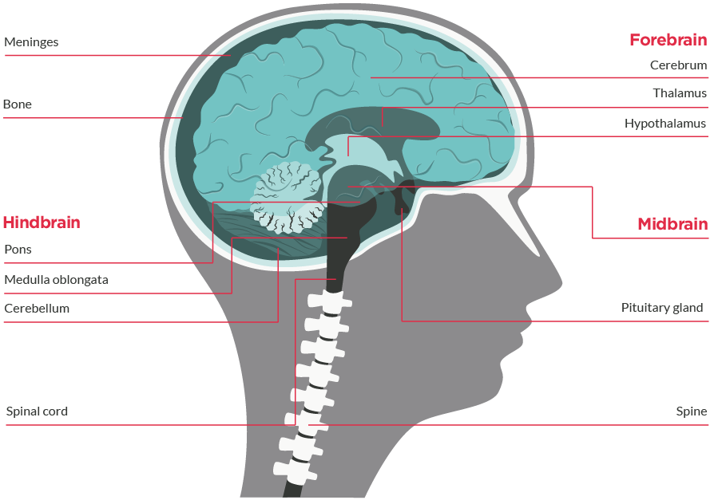
Glioma is a general term used to describe all tumours which arise from glial cells. Glial cells are the cells which surround, support and protect the neurons (nerve cells) in our brain and spinal cord, by providing them with oxygen, nutrients and removing dead cells.
There are different types of glial cell, each of which plays a different role in supporting the neurons. The main types are astrocytes, oligodendrocytes and ependymal cells.
Brain tumours that grow from astrocytes are called astrocytomas.
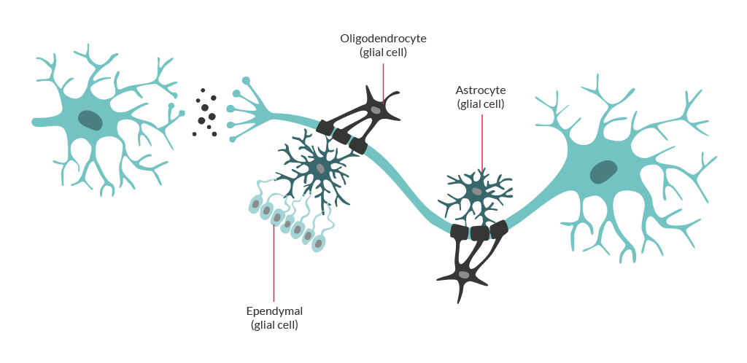The majority of DIPGs are astrocytomas. Although the structure of DIPG cells resembles that of high grade astrocytomas originating in other parts of the brain, there are also a number of possible differences which researchers are currently trying to identify and explain.

What are the causes of DIPG?
The cause of brain tumours, including DIPG, is not yet known. This can be one of the most difficult things to accept as a parent as it can leave you feeling helpless. Brain tumours are nobody’s fault. There is no research that shows that anything you may have done during pregnancy or in your child’s early infancy could have caused your child’s brain tumour.
At the moment, there is ongoing research aimed at discovering the genetic causes of DIPG which could help diagnose DIPGs earlier and develop new treatments in the future.

What are the effects of DIPG?
The signs of a DIPG vary as the pons and surrounding structures which may be affected by DIPG are responsible for a variety of different body functions. Below are the different structures which might be affected by DIPG tumour growth and the side-effects which might develop as a result:
Cranial nerve
If a DIPG presses against the nerves leaving the brain which control our senses and facial muscles, known as the 'cranial nerves', this might cause abnormal alignment of the eyes or/and double vision (diplopia). Weakness of facial muscles or facial asymmetry (one side of the face appearing different from the other) may also result from a DIPG pressing against cranial nerves.
Long tract
Long tract refers to a bundle of nerves which passes from the brain down through the spinal cord to the muscles of the body, controlling movement. Due to the fact that the long tract passes though the pons, a DIPG might cause arm and leg weakness.
Cerebellum
The cerebellum is an area at the back of the brain (see the previous diagram). If a DIPG affects the cerebellum, a child may develop problems with co-ordination, walking and speaking.
In a relatively small number of cases, growth of a DIPG might block the drainage of cerebrospinal fluid (the fluid which surrounds and nourishes the brain), causing a build-up of pressure in the head. This is known as hydrocephalus which is very common in other types of brain tumours. Hydrocephalus can cause symptoms such as headache (especially in the morning), nausea and fatigue.
Not all cases of DIPG are identical and a child might show any combination of these symptoms.
For information on symptoms of brain tumours please visit: headsmart.org.uk

How are DIPGs diagnosed?
If your doctor (GP) suspects your child has a brain tumour, they will refer them to a paediatrician or emergency department doctor. These specialists will ask questions about your child’s health and give them a physical examination. They will also test their nervous system (called a neurological examination). This involves looking at your child’s vision, hearing, alertness, muscle strength, co-ordination, and reflexes. They will also look at the back of their eyes to see if there is any swelling of the optic disc (the optic disc is where the optic nerve from the brain enters the eye). Any swelling is a sign of raised pressure inside the skull, which could be a sign of a brain tumour.
If they suspect the presence of a brain tumour they will send your child for an MRI (magnetic resonance imaging) or CT (computerised tomography) scan to confirm whether a brain tumour is present.
For information, see the Scans for children fact sheet or our children’s animation at: bit.ly/Jake-Scans
Following scans, some types of brain tumour are operated on by a neurosurgeon to run more tests on it to confirm exactly what it is and remove as much of the tumour as possible .
Unfortunately, due to the position of DIPGs deep in the brain and close to vital structures, these procedures are often not performed for this type of tumour.
A specialist can diagnose a DIPG by an MRI scan alone since DIPGs have a very distinctive appearance on scans.

How are DIPGs treated?
As mentioned above, if your child is diagnosed with a DIPG, having surgery to remove the tumour may not be a viable option due to the dangers of operating on critical areas of the brain.
The standard of treatment for DIPGs is radiotherapy, which is usually administered over 3 to 6 weeks depending on the type of radiotherapy that is deemed best for your child (with a daily dose given Monday to Friday). Your child might also be given steroids during this period to help reduce some of the pressure caused by the tumour and radiation treatment.
For more information, please see our Radiotherapy for children fact sheet or our children’s animation at: bit.ly/Jake-radiotherapy
Based on the findings of various studies, chemotherapy drugs currently used to treat adult high grade gliomas in other parts of the brain (such as Temozolomide) have been shown not to be effective in treating childhood DIPGs, so your child is unlikely to receive this type of treatment.
Researchers are currently working on finding out more about the specific genes and molecules involved in DIPG tumour formation.
Knowing more about DIPGs will enable drug developers to create treatments for DIPGs which are more targeted and effective.

What is the prognosis for DIPGs?
Due to the fact that the treatment options for DIPGs are limited, the prognosis for children diagnosed with a DIPG is relatively poor.
70% of children with DIPGs are not likely to survive more than a year and 90% of children with DIPG do not survive to two years after diagnosis.
While these numbers give a general overview of prognosis for DIPGs, it is important to remember that each child’s journey is unique and not necessarily represented by these general figures. Also, these statistics do not take into account your child’s individual circumstances such as their general health and the quality of care provided by their hospital or treatment centre. If your child has been diagnosed with a DIPG, it would be helpful to focus more on their treatment and wellbeing on a day-by-day basis.
Given the relative lack of treatment options for DIPGs, you might also want to look for any clinical trials that might be available for your child. Even if your child is not given a new treatment whilst on a clinical trial, they will be given conventional (standard) treatment while also having their health monitored very closely. You can look for clinical trials on our website: thebraintumourcharity.org/research/clinical-trials
Receiving any diagnosis of a brain tumour can be devastating and it can be very difficult to come to terms with what you have been told regarding your child’s prognosis. We are here to help.
You can talk to someone who understands on our Support & Info Line, which can be reached via our free phone number 0808 800 0004 or by email at support@thebraintumourcharity.org.
It is available to anyone affected by a DIPG diagnosis - patient, family or friends. Specifically for parents, our central team can connect you with our dedicated Children and Families Service.
There is also our very supportive online community in our closed Facebook group, where you may be able to talk to somebody whose child has received a DIPG diagnosis: bit.ly/facebookparentsgroup

What if I have further questions?
If you require further information, any clarification of information, or wish to discuss any concerns, please contact our Support and Information Team, which includes a dedicated Children and Families Worker:
- Call 0808 800 0004 (free from landlines and most mobiles including 3, O2, EE, Virgin and Vodafone)
- Email support@thebraintumourcharity.org
- Join our closed Facebook group: bit.ly/supportonfacebook

About us
The Brain Tumour Charity makes every effort to ensure that we provide accurate, up-to-date and unbiased facts about brain tumours. We hope that these will add to the medical advice you have already been given.
The Brain Tumour Charity is at the forefront of the fight to defeat brain tumours and is the only national charity making a difference every day to the lives of people with a brain tumour and their families. We fund pioneering research to increase survival, raise awareness of the symptoms and effects of brain tumours and provide support for everyone affected to improve quality of life.
We rely 100% on charitable donations to fund our vital work. If you would like to make a donation, or want to find out about other ways to support us including fundraising, leaving a gift in your will or giving in memory, please visit us at thebraintumourcharity.org, call us on 01252 749043 or email fundraising@thebraintumourcharity.org

About this fact sheet
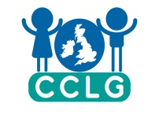
This fact sheet has been written and edited by The Brain Tumour Charity’s Support and Information Team and is supported by the Children’s Cancer and Leukaemia Group (CCLG).
The accuracy of medical information has been verified by leading health professionals specialising in neuro-oncology. Our fact sheets have been produced with the assistance of patient and carer representatives and up-to-date, reliable sources of evidence. If you would like a list of references for any of the fact sheets, or would like more information about how we produce them, please contact us.

Title of fact sheet

Your notes

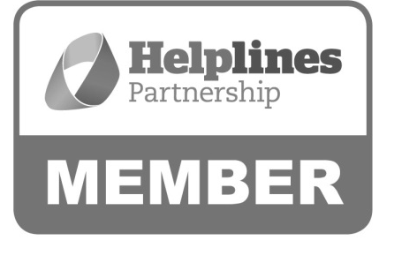

Hartshead House
61-65 Victoria Road
Farnborough
Hampshire
GU14 7PA
01252 749990
enquiries@thebraintumourcharity.org
www.thebraintumourcharity.org
© The Brain Tumour Charity 2015. Registered Charity Number 1150054 (England and Wales) and SC045081 (Scotland).
Version 1.0 (clear print), first produced in standard print format January 2016. Review date, 2019.

