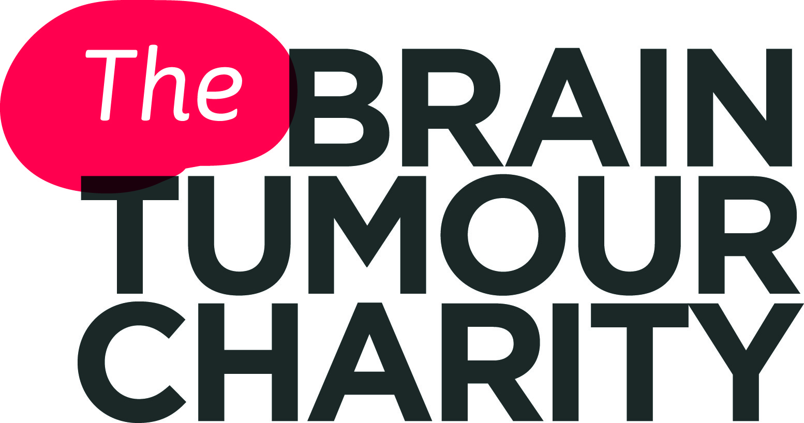

Communication difficulties and brain tumours
Communication allows us to tell people about ourselves and how we feel. It plays a large part in our independence in our personal and professional lives. It is an essential part of who we are as human beings.
The ability to communicate is something we often take for granted. When communication difficulties occur, they can make us feel frustrated, angry, embarrassed and isolated from the world.
Understanding communication difficulties and knowledge of coping strategies can help people affected by a brain tumour (and those around them) to feel more able to cope and so reduce these feelings.
In this fact sheet:
- How can brain tumours affect communication?
- What communication difficulties might someone with a brain tumour experience?
- Emotional aspects of communication difficulties
- How to help communication

How can brain tumours affect communication?
It is important to realise that not everyone with a brain tumour will experience communication difficulties, or they may be so mild that they do not greatly affect daily life.
Whether and how a brain tumour affects your communication skills will depend on where it is in the brain.
Each section or lobe of the brain (see diagram below) is responsible for different functions, some of which are involved in communication.
For example, the frontal lobe is involved in language production and the temporal lobe is involved in understanding language.
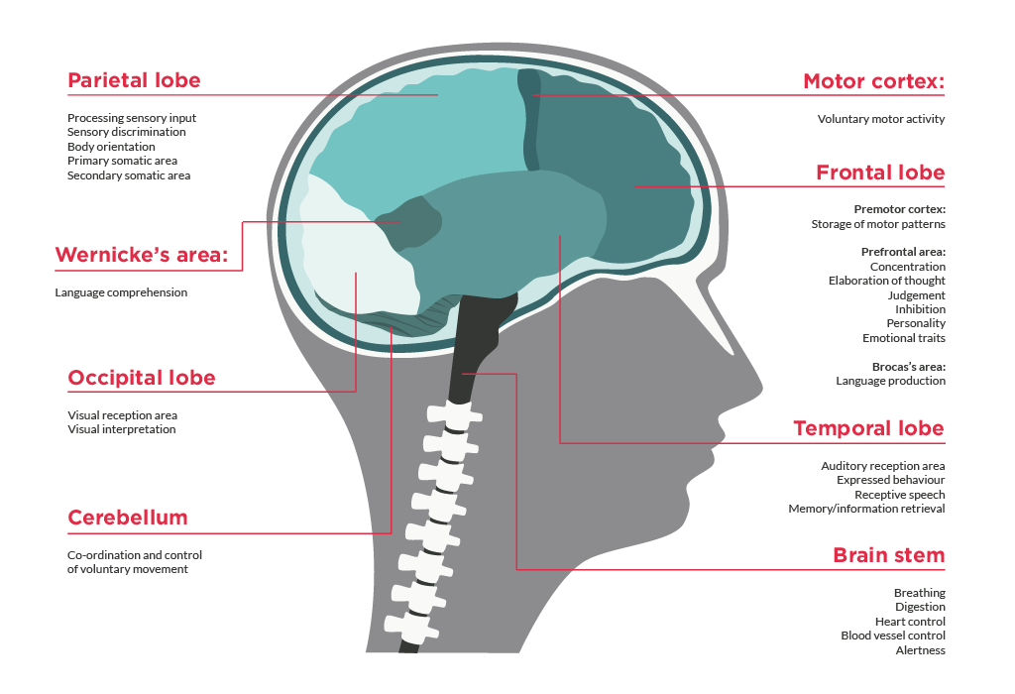As a result, if your tumour is in one of these lobes, the pressure the tumour is causing on that part of your brain, may affect your communication skills.

The brain is also divided into two hemispheres - left and right. The side on which your tumour is located, as well as the lobe, can affect the type and likelihood of communication effects.
For example, if your tumour is located in the left hemisphere, you are more likely to experience language and speech difficulties, as this is where the language areas are generally found. (It is important to note that for some people, the language areas are found in the right hemisphere.)
Surgery can also cause communication difficulties if the area of the brain operated on is involved in communication.
If these difficulties are due to the natural swelling that occurs after surgery, the effects may be temporary.
However, if some of the tumour remains causing pressure on the brain, or some of the brain tissue involved in communication skills has been removed, the effects may be more permanent.

What communication difficulties might someone with
a brain tumour experience?
If you have a brain tumour, you may experience a range of different communication difficulties. These include:
- Language impairment (also known as ‘dysphasia’)
Includes difficulties understanding language and producing language, as well as with reading and writing
- Speech difficulties
- Cognitive communication difficulties
Problems with cognitive functions, such as memory, attention, social cognition, can lead to communication difficulties due to forgetting words, losing the thread of a conversation, or not knowing when to talk and when to listen during a conversation
(For more information on cognitive effects, please see the Cognition and brain tumours fact sheet.)
The most common communication difficulty experienced by people with brain tumours is dysphasia.
Sometimes the term ‘aphasia’ is used, even though the more correct term is ‘dysphasia’. (Aphasia really means the complete lack of language, whereas dysphasia means problems with language).

What is dysphasia?
Dysphasia is a condition caused by damage to the parts of the brain that are responsible for understanding and producing language. It also affects speaking and writing in the same way.
This means you may have difficulty understanding words you hear or read, as well as in producing words (spoken or written).
It is important to note that dysphasia does not affect intellect although, unfortunately, this is a common misperception.
Dysphasia can vary in the degree of difficulty it causes with communication. It can sometimes affect just one aspect (e.g. the ability to write), but it is more common for several aspects to be affected.
In people with brain tumours, the severity of the dysphasia can progress as the tumour grows.
There are various types of dysphasia (which use the term’ aphasia’). The three most common types are: ‘Broca’s aphasia’, ‘Wernicke’s aphasia’ and ‘global aphasia’. (Global aphasia is very rare, but essentially involves symptoms from both Broca’s and Wernicke’s aphasia.)
Each are associated with different difficulties. The type of dysphasia you experienced will depend upon which part and how much of your brain
is affected.
It is important to remember that you are unlikely to have clear cut symptoms from one type of dysphasia as described below.
Broca’s aphasia
Broca’s aphasia can occur when you have damage to an area of the frontal lobe, known as Broca’s area, which is responsible for language production.
If you have this type of expressive, non-fluent dysphasia you may have difficulty speaking and may only be able to produce a small number of words in halting sentences, for example “want … tea … sugar”.
It is usually possible for other people to understand your speech, but it may take you some time to say what you want to say.
People with Broca’s aphasia may:
- Not be able to speak at all
- Have difficulties speaking or writing in full sentences and may only use one or two words
- Speak with pauses or not be able to say the word they would like to say
- Get words muddled up (for example saying “wife” instead of “daughter”) and confuse “yes” and “no”
- Be able to describe an object, but not name it
- Only be able to say a few words, which may be linked to emotions and could be swear words
If you have Broca’s aphasia, you may not always be aware that your
speech is not as you intend, but you will be aware that you have a communication difficulty.

Wernicke’s aphasia
Wernicke’s aphasia can occur when there is damage to the part of the temporal lobe, known as Wernicke’s area, which is responsible for understanding language.
This type of ‘receptive dysphasia’ affects language comprehension and the ability to produce meaningful language.
You may have speech that sounds fluent and has a normal rhythm, but it is, in fact, made up of ‘non–words’. As a result, other people will not be able to understand what you are trying to say.
You may also be unable to understand what others are saying.
A person with Wernicke’s aphasia may also:
- Not understand long sentences and forget the beginning of what
has been said
- Have difficulty understanding if there is background noise or several people speaking at once
- Be able to read headlines, but not the main body of the text
- Be able to write, but not read back what they have written
In general, someone with Wernicke’s aphasia will not be aware that they have a communication difficulty.

Emotional effects of dysphasia

Being able to think clearly, but unable to find or write words; or understand what people are saying; or read; or use numbers, money or tell the time, can be exceedingly frustrating.

You may feel angry and in despair.

Being able to communicate effectively is important to many aspects of daily life. As a result, you may feel emotionally 'cut off' from those around you, and your relationships may suffer.

Many people feel embarrassed, lose confidence and may become anxious about being in social situations and so withdraw from them. It could also affect your employment.

As a result, dysphasia can be extremely isolating. Depression is not uncommon in people affected by dysphasia.

(Please see our fact sheet on Depression and brain tumours, for more information.).

Carers, family and friends can also find aphasia confusing and frustrating. They often report feeling lonely and isolated too. They can feel emotions such as helplessness or even guilt watching their loved one struggle to communicate. Their relationship has also changed and they may now be the sole earner, which can lead to financial difficulties.
For this reason, if you are a carer, it is important that you look after yourself. It is well known, but often forgotten, that you can only care well if you care for yourself. (Please see our Carers - looking after yourself fact sheet, for more help with this.)
You may also find useful the suggestions for helping your loved one cope with their dysphasia further on in this fact sheet.

Many carers have found that it is important not to do too much for their loved one just because it is easier, and to remember that the person with aphasia is:

Still an intelligent person

Knows what they want to say

Can still make their own decisions

What might help communication?
There are some simple changes you can make that may help you if you are experiencing communication problems.
As communication is a two way process, the way that those around you communicate with you is also very important.
One of the key ways they can help is to be supportive and to adapt the way they communicate in order to facilitate your understanding and self-expression.

If you are experiencing communication difficulties:
- Try to create a relaxed environment - dysphasia often worsens with stress
- Reduce background noise and distractions
- Consider taking a break if you are tired

If someone you care for is experiencing communication difficulties:
- Don’t rush your speech - speak clearly and at a steady pace
- Give one point at a time rather than all of the information at once
- Don’t be tempted to speak more loudly - remember that the person does not have a problem with their hearing
- If the person has not understood you, try rephrasing what you have said
- If the person is having difficulty with a particular word, you could ask them to describe it instead
- Use all forms of communication, including mime, gesture, intonation, writing, drawing, and facial expressions. There are also communication boards and other aids that can help. (Please see the Resources section of this fact sheet for more information.)
- Make giving answers easy. For example, instead of asking “Would you like tea or coffee?”, you could ask, “Would you like tea?”
- Don’t pretend to understand what the person has said if you do not. They will probably be aware that you are doing this and you could leave them feeling very frustrated
- Take care not to talk down to the person with the communication difficulty - the problem is not with their intelligence
- Don’t interrupt or fill in words for a person unless they ask you to
- Relax and be natural
- Consider taking a break if you are both tired

What interventions are available to help with speech and communication problems?
Dysphasia is commonly caused by a one off event (for example, a stroke or
a head injury) and, in these circumstances, some degree of natural recovery is usual.
When a brain tumour is the cause, however, dysphasia may actually worsen if
a tumour grows.
You may have been referred to a speech and language therapist (SLT) following surgery for your tumour.
(Please see our fact sheet on the Multidisciplinary Team [MDT]).
If not, or you have not had surgery, you can ask your health team to be referred to an SLT.
In order to offer the best help, the SLT first gives you a variety of spoken and written tests, such as naming objects, engaging in conversation, telling a story or joke, or writing a shopping list.
These are used to assess which sort of communication difficulties you are having and to what degree. They will then work with you, using various tools and exercises, towards three key goals:
- Relearning lost or damaged communication skills (if possible)
- Making the best use of remaining communication skills
- Finding new ways of communicating

Resources
While The Brain Tumour Charity cannot recommend any specific organisations, the following organisations provide support with communication difficulties:
- Speakability - Provides information and support groups
speakability.org.uk 0808 8089572
- Brain and Spine Foundation - Provides information and support on neurological disorders for patients, carers and health professionals
brainandspine.org.uk 0808 808 1000
- Connect - A charity for people living with aphasia. They provide meet-ups, a coffee shop and counselling
ukconnect.org 0207 367 0840
- The Royal College of Speech and Language Therapists
Offer speech and language therapy services
rcslt.org For general information and professional enquiries -
Tel: 020 7378 3012; Email: info@rcslt.org
- Lynne Liddle Brain Cancer Trust - Can provide iPads to brain
tumour patients to help them communicate
lynneliddlebraincancertrust.co.uk
- Amy Speech & Language Therapy, Inc. - Has sets of free,
downloadable communication boards for adults and children on
a range of different topics. amyspeechlanguagetherapy.com/communication-boards.html

What if I have further questions?
If you require further information, any clarification of information, or wish to discuss any concerns, please contact our Support and Information Team:
- Call 0808 800 0004
(Free from landlines and most mobiles,
including 3, O2, EE, Virgin and Vodafone)
- Email support@thebraintumourcharity.org
- Join our closed Facebook groups:
bit.ly/facebooksupportgroup
bit.ly/carersupportgroup

About us
The Brain Tumour Charity makes every effort to ensure that we provide accurate, up-to-date and unbiased facts about brain tumours. We hope that these will add to the medical advice you have already been given. Please do continue to talk to your health team if you are worried about any medical issues.
The Brain Tumour Charity is at the forefront of the fight to defeat brain tumours and is the only national charity making a difference every day to the lives of people with a brain tumour and their families. We fund pioneering research to increase survival, raise awareness of the symptoms and effects of brain tumours and provide support for everyone affected to improve quality of life.
We rely 100% on charitable donations to fund our vital work. If you would like to make a donation, or want to find out about other ways to support us including fundraising, leaving a gift in your will or giving in memory, please visit us at thebraintumourcharity.org, call us on 01252 749043 or email fundraising@thebraintumourcharity.org

About this fact sheet
This fact sheet has been written and edited by The Brain Tumour Charity's Support and Information Team. The accuracy of medical information has been verified by a leading neuro-psychologist. Our fact sheets have been produced with the assistance of patient and carer representatives and up-to-date, reliable sources of evidence. If you would like a list of references for any of the fact sheets, or would like more information about how we produce them, please contact us.

Communication difficulties

Your notes

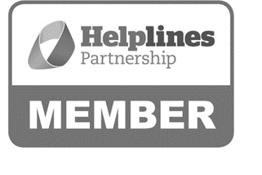

Hartshead House
61-65 Victoria Road
Farnborough
Hampshire
GU14 7PA
01252 749990
enquiries@thebraintumourcharity.org
www.thebraintumourcharity.org
© The Brain Tumour Charity 2016. Registered Charity Number 1150054 (England and Wales) and SC045081 (Scotland).
Version 3.0 (clear print), first produced in standard print format February 2016. Review date, 2019

