Antineoplaston therapy

Antineoplaston therapy is an alternative cancer therapy available in America, which was developed by Dr S R Burzynski in the 1970s. It has long been a controversial treatment for various types of cancers.
While some people promote antineoplaston therapy as being an effective cure for cancer, there is, to date, no scientific evidence (as defined below) that supports this claim.

This fact sheet will give you an overview of antineoplaston therapy and some of the literature behind the theories.

In this fact sheet:
- What are antineoplastons?
- What is antineoplaston therapy?
- Why is this treatment controversial?
- Other studies
- Possible side-effects

What are antineoplastons?
Antineoplastons are chemical compounds found naturally in blood and urine. These compounds are made up of amino acids (the building blocks of proteins) and peptides (molecules made up of two or more amino acids). It has been suggested that antineoplastons have anti-cancer properties.
What is antineoplaston therapy?
Antineoplaston therapy is an alternative cancer therapy which was developed by Dr S R Burzynski in the 1970s and has long been a controversial treatment for various types of cancers.
Burzynski believes that antineoplastons form a natural part of our body’s immune (defence) system and that people with cancer do not have enough of these compounds. The Burzynski clinic proposes that increasing these compounds will result in the body fighting the cancer and result in tumour shrinkage.
In the initial stages, Burzynski extracted antineoplastons from blood and urine, however he is now able to make them in the laboratory. To get the antineoplastons into the body they are taken in tablet form or injected.
Why is this treatment controversial?
While the Burzynski clinic promotes antineoplaston therapy as being an effective cure for cancer there is, to date, no scientific evidence that supports this claim.
To qualify as scientific evidence studies must:
- Be published in a peer-reviewed scientific journal (a publication that contains original articles that have been written by research scientists and evaluated for technical and scientific quality and accuracy by experts within the same field)
- Report a therapeutic outcome, such as tumour shrinkage or extension of life
- Describe clinical findings in such as way that evaluation can be made of methods followed, results obtained and study replications can be conducted.

Some studies on antineoplaston therapy have been published, however, for the most part, these have been authored by Dr Burzynski himself or his colleagues at the Burzynski clinic and do not meet the criteria needed to qualify as scientific evidence. Although Burzynski’s studies have reported remission, independent studies have not been able to replicate his results.
In addition to the question over published independent articles there is a question over the level of clinical trials that have been carried out (for further information see the clinical trials fact sheet). To date, no Phase III trials have been conducted into the benefits of antineoplastons (this phase uses randomised clinical trials to look at whether a new treatment is better than an existing treatment). Current publications, written by Burzynski and independent researchers, have only included research trials at Phase I level (this phase looks at whether a treatment is safe or not) and Phase II level (looks at whether a new treatment does what is hoped).
Due to the lack of clinical evidence, antineoplastons have not been approved by the US Food and Drug Administration for the treatment of any type of disease. The Burzynski clinic therefore only offers antineoplaston therapy as part of a clinical trial.
The status of antineoplaston therapy as a clinical trial raises further controversy. It is highly unusual for clinical trials to last for more than a few years. Antineoplaston therapy is still categorised as a trial more than 34 years on. Furthermore, those wishing to partake in the trial are being asked to pay tens of thousands of dollars for treatment. This situation is not the norm in the UK.
It is estimated by the American Cancer Society that a year’s course of treatment at the Burzynski clinic costs between $30,000 - $60,000. With travel and accommodation, a person based in the UK could expect to need to raise in the region of £100,000 for a treatment which is, as yet, unproven.
Other studies
A report published by the United States Congressional Office of Technology Assessment (OTA) in 1990 concluded that:
"Despite a substantial number of preliminary clinical studies published by Burzynski and his associates and an attempt at a 'best case' review, there is still a lack of valid information to judge whether this treatment is likely to be beneficial to cancer patients."
The OTA report also criticized Burzynski's research process and noted that his definitions of advanced cancer and of complete and partial cancer remission were not used in accordance with generally accepted definitions.
In 1991, the National Cancer Institute (NCI) reviewed several 'best cases' (involving patients with brain tumours) chosen by Burzynski. The article, published in the Journal of the National Cancer Institute, stated:
"Two NCI investigators independently reviewed the case histories of some patients treated with antineoplastons. At the investigators' recommendation, the NCI examined the case histories, pathology slides and imaging studies from seven patients with primary brain tumours … the site visit team and, subsequently, the [NCI] Division of Cancer Treatment's Decision Network Committee believed that evidence of possible antitumor effect was demonstrated."
The NCI concluded that these results warranted further investigation through clinical trials at other medical centres but, because of disagreement between NCI researchers and Burzynski, the clinical trials were terminated in 1995.
By 1999, the researchers concluded that only 6 of the 9 patients treated in that study could be evaluated according to the study's initial requirements. None of the six showed evidence of tumour shrinkage.
Possible side effects
Antineoplastons may have not been thoroughly tested to find out how they interact with medicines, foods or dietary supplements and full studies of interactions and effects are not often available. Because of this, any information on side effects must be considered incomplete.

What if I have further questions?
If you require further information, any clarification of information, or wish to discuss any concerns, please contact our Support and Information Team.
- Call 0808 800 0004 (free from landlines and most mobiles including 3, O2, Orange, T-mobile, EE, Virgin and Vodafone)
- Email support@thebraintumourcharity.org
- Join our online forums at www.thebraintumourcharity.org/forums

About us
The Brain Tumour Charity makes every effort to ensure that we provide accurate, up-to-date and unbiased facts about brain tumours. We hope that these will add to the medical advice you have already been given. Please do continue to talk to your doctor if you are worried about any medical issues.
We are the UK’s leading brain tumour charity. We fund scientific and clinical research into brain tumours and offer information and support to those affected, whilst raising awareness and influencing policy.
We rely 100% on charitable donations to fund our vital work. If you would
like to make a donation, or want to find out about other ways to support us including fundraising, leaving a gift in your will or giving in memory, please visit us at www.thebraintumourcharity.org or call 01252 749990 or email fundraising@thebraintumourcharity.org.

About this fact sheet
This fact sheet has been written and edited by The Brain Tumour Charity’s Support and Information Team. The accuracy of medical information has been verified by a leading neuro-oncologist. Our fact sheets have been produced with the assistance of patient and carer representatives and up-to-date, reliable sources of evidence. If you would like a list of references for any of the fact sheets, or would like more information about how we produce them, please contact us.

Disclaimer:
Patients must seek advice from their medical teams before beginning or refraining from taking any medication. The Brain Tumour Charity does not accept any liability to any person relating to the use of any such information.

Antineoplaston therapy

Your notes

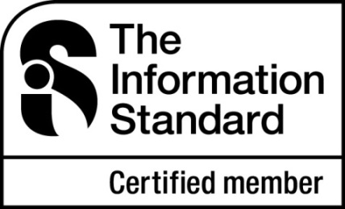
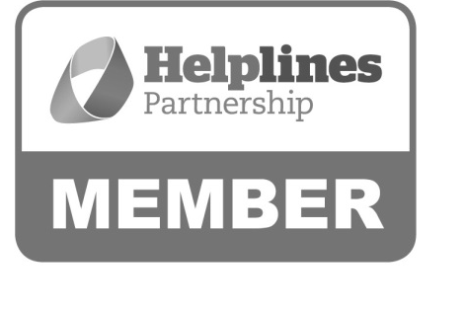

Hartshead House
61-65 Victoria Road
Farnborough
Hampshire
GU14 7PA
01252 749990
enquiries@thebraintumourcharity.org
www.thebraintumourcharity.org
© The Brain Tumour Charity 2014. Registered Charity Number 1150054 (England and Wales) and SC042096 (Scotland).
Version 1.0 (clear print), first produced in standard print format January 2013. Review date, 2016.

