Proton Beam Therapy
Proton Beam Therapy (PBT) is a highly specialised form of radiotherapy that uses a beam of high energy ‘protons’ rather than high energy X-rays. Protons are very small particles that are small parts of atoms.
One of the key advantages of PBT over conventional radiotherapy is that it is more targeted, doing less damage to the healthy tissue around the tumour and in the rest
of the brain. This means it causes fewer side-effects.
PBT, however, is only suitable for
a few types of brain tumour, is currently not available in the UK for brain tumour use, and does not lead to better outcomes than conventional radiotherapy in
most cases.
In certain circumstances the NHS can refer people to receive PBT outside the UK.

In this fact sheet:
- What is PBT and how does it compare to conventional radiotherapy?
- Who can have PBT?
- What does PBT involve?
- After treatment and side-effects
- Answers to some other questions that you may have about PBT
What is PBT?
PBT is a specialised form of radiotherapy that involves directing a beam of protons (energised sub-atomic particles) specifically at the tumour.
A machine (called a cyclotron or particle accelerator) speeds up the protons causing them to gain energy. Once a high level of energy is reached the protons are then beamed out of the machine and guided
by magnets towards the tumour.
Protons accurately release most of their cell-killing energy at a particular depth in tissue. This depth can be varied by the medical team who programme the PBT machine.
In other words, in PBT the beam of protons can be set up to stop once it has ‘hit’ the tumour cells (and travelled for a safe margin past the tumour to capture any tumour cells beyond the visible edge of the tumour).
This means that PBT destroys the tumour cells whilst not affecting so many of the surrounding cells. In particular, PBT delivers very little radiotherapy in a path through the rest of the brain on the other side
of the tumour, unlike other high energy beams (X-rays) used in conventional radiotherapy.

What is the benefit of PBT over conventional radiotherapy?
It is the ability to ‘stop’ more quickly at a prescribed depth that gives PBT an advantage over conventional radiotherapy.
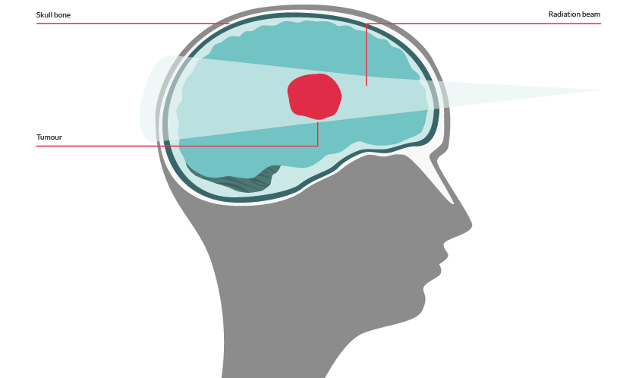
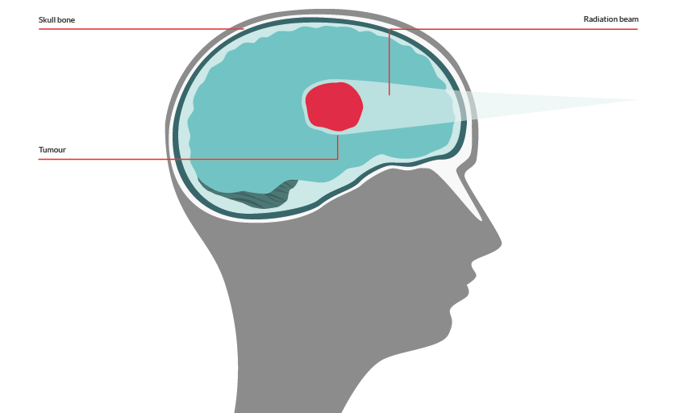
Conventional radiotherapy beam
Proton Beam Therapy beam
In conventional radiotherapy, the beam of energized particles (X-rays) takes longer to slow down after passing through the tumour and so travels further through the rest of the brain. As a result, conventional radiotherapy causes some damage to the healthy cells beyond
the tumour.
Although healthy cells are more able to repair themselves than the rapidly dividing tumour cells, the increased amount of initial damage
to healthy cells with conventional radiotherapy, can cause more side-effects in the short-term. Some of this damage may also remain unrepairable, leading to long-term effects. PBT limits this damage.
In addition, the reduced damage to surrounding healthy tissue in PBT, means the tumour can be given a higher radiation dose than they would with conventional radiotherapy.
PBT, being highly targeted towards the tumour, also means that it is often possible to treat areas closer to very sensitive structures, such
as the spinal cord or optic nerve.
Is PBT effective?
As PBT is a relatively new therapy and is usually used for rare types of cancer, there is little systematic evidence that can be gathered about its effectiveness compared to conventional radiotherapy, particularly in relation to long-term side-effects.
PBT may cause less damage to healthy tissue, but it is important to realise that:
- The way PBT-type radiation works when it reaches the target is much the same as conventional radiotherapy
- It is still unclear whether PBT is as good at destroying cancerous tissue as conventional radiotherapy
- The quicker ‘stopping’ of the radiation in PBT means there is a sharp cut-off between adequate dose and low dose areas, so getting the target right is very important
- It requires extra training and skill to work out the most appropriate depth and dosage of PBT, which varies according to tumour type and behaviour
- It is harder to check what is actually being treated during PBT treatment - conventional radiotherapy can use imaging immediately before or during treatment to check the accuracy and precision of the treatment area, which is important when near to critical structures, such as the spinal cord or optic nerve
- People who travel to receive PBT, often respond well, but these are ‘optimally chosen candidates’ who are more likely to do well
More research is needed to establish:
- Whether PBT is more effective than conventional radiotherapy (or even equally as effective)
- If long-term effects within the field of radiation are reduced
- The long-term survival data for different tumour types

Who can have PBT?
PBT is not suitable for everyone. Whether you or your child can have PBT depends on many factors.
Brain tumour type
PBT is not suitable for all types of brain tumour. It works best for smaller tumours and those where the edges are clearly defined.
It is also useful where the tumour is close to very important structures like the spinal cord or optic nerve, or when it is important to reduce the damage caused to surrounding normal tissue as much as possible
e.g. brain tumours in young children whose brains are still developing.
There is a nationally approved list of tumour types that are suitable for referral.
With regards to brain tumours, these include:
Children, teenagers and young adults:
  - Ependymoma
  - Optic pathway and other selected low grade glioma
  - Craniopharyngioma
  - Pineal parenchymal tumours (not Pineoblastoma)
  - Base of skull & spinal chordoma
  - Base of skull chondrosarcoma
Adults:
  - Base of skull & spinal chordoma
  - Base of skull chondrosarcoma
Though not on the approved list, PBT has sometimes been used to treat medulloblastomas in children.
However, diagnosis alone is not enough. PBT will only be given
if it is thought it will give a significant advantage over conventional radiotherapy.
Other factors
There are many factors which will affect whether PBT will give an advantage over conventional radiotherapy. These include:
  - Timing of when the radiotherapy needs to be given
(Referral abroad may delay the giving of radiotherapy for longer than the health professionals would advise)
  - Timing of when the radiotherapy needs to be given in relation to other treatments, such as chemotherapy
(It is most important that PBT seamlessly links with surgery and chemotherapy. Disruption in the pathway, and the resulting delays, can lead to less intensive therapy and a reduction in tumour control. This could counteract any longer term benefits. This is particularly important in the treatment of high grade, ‘malignant’ brain tumours, such as medulloblastoma)
  - Where the tumour is within the brain
  - How much radiation needs to be given
- Patient age and how well they are otherwise
- How much of the tumour has been removed by surgery
- Ability to travel (as PBT is currently not available in the UK)
As a result, if your child or you has a diagnosis on the approved list, PBT may still not be the best radiotherapy option.
The other thing to bear in mind is that as PBT is a relatively new therapy and, although it may cause less damage to healthy tissue, it has yet to be proved conclusively that it is as good at destroying tumour cells as conventional radiotherapy.
(However, a recent study did find that it had similar survival outcomes to conventional radiotherapy in medulloblastomas, but there remains no evidence that it provides better results than conventional radiotherapy.)
Cancer Research UK estimates that only one in 100 people with cancer would be suitable for PBT (and that is people with all types of cancer). It is therefore important for people to avoid an exaggerated impression of the potential benefits.
You can discuss the various treatment options available to you or your child with your Clinical Oncologist to make an informed decision about the right course of treatment.
If you are unhappy about a decision not to give PBT, you can always ask for a second opinion from another health professional. This can feel a bit daunting, but please remember that although you do not have a legal right to a second opinion, a healthcare professional will rarely refuse to refer you for one. Asking for a second opinion will not affect your treatment.
Your GP or your neuro-oncologist can help to arrange a second opinion. Or if you have any concerns or want to know how to ask for a second opinion, please talk to us via our Support & Info Line - 0800 800 0004 or support@thebraintumourcharity.org
What happens next if our oncologist considers PBT to be suitable?
If the Clinical Oncologist feels that PBT may be suitable for you/your child, they will, with your agreement, refer your/your child’s case to the Proton Clinical Reference Panel (PCRP) of the UK Proton Overseas Programme for consideration. This is the same for patients from England, Wales, Scotland and Northern Ireland.
There is a strict set of criteria that a patient must fulfil for
a referral for PBT to be made. Funding for treatment will not be approved outside these strict criteria. It is also unlikely that the treatment will be successful if these criteria are not filled.
Referral process
The referral to the panel must be supported by the local MDT
(Multi-Disciplinary Team) and made by a Consultant Clinical Oncologist who has seen and assessed you/your child and who has discussed it with you.
The consultant completes a referral form and sends your/your child’s medical records, including images of the tumour, to the PRCP. They will decide if PBT will be of more benefit compared to conventional radiotherapy.
This process generally takes at least two weeks, but can be longer if the panel needs to query any of the information they receive. Your consultant will inform you of their decision.
In Scotland the Clinical Oncologist refers first to the Scottish
Non-Standard Radiotherapy Advisors, who decide whether to refer on to the PCRP. In Wales, Northern Ireland, the Channel Islands and the Isle of Man, funding also has to be agreed by the local health boards/trusts.
If PBT is approved by the panel, your (or your child’s) medical records and tumour images will then be sent by your consultant to one of the approved treatment centres abroad. The treatment centre will discuss and review the case and make the final decision about whether PBT treatment will be offered. They will then inform your health team.
This part of the process can take up to three weeks. Additional tests to help assess your/your child’s suitability may be requested. Sometimes further surgery in the UK is also requested before PBT can be offered.
If the treating centre approves treatment, then your local NHS Trust will contact you to discuss travel arrangements and make sure you have the appropriate travel documents (passports, visas, insurance etc.). This part of the process, including arranging travel, can mean it is another three weeks before you arrive at the treatment centre.
Consultations, a planning scan and the actual planning of the treatment will then be done. This can take up to three weeks.
It is important to realise, therefore, that the whole referral process, from when your consultant suggests this could be appropriate treatment to receiving the first PBT, can take nearly three months (11 weeks). Also, at any stage, the case can be refused on the grounds of PBT not being the best option for you/your child.
Where can I have PBT?
At the moment, brain tumours are not treated with PBT in the UK, as UK hospitals do not have appropriate PBT machines. (Current UK PBT machines are low energy machines and cannot deliver the protons at a high enough energy to reach the depth in the body where brain tumours are situated.)
However, the NHS will refer appropriate cases to approved treatment centres in the USA or Europe (Switzerland). Children are normally treated in the USA.
There are other (private) centres overseas, but people/parents should be aware that these can be expensive, may not have sufficiently trained staff and often don’t offer other treatments, such as chemotherapy, which may be required alongside the PBT. The lack of these additional treatments could have an effect on the overall effectiveness of the treatment.
The NHS is planning to open two PBT centres suitable for treating brain tumours in the UK. One at The Christie in Manchester (due to open in 2018) and one at UCLH (University College London Hospital) in London, which is expected to treat patients by 2019. (Please note that these dates may be subject to change.)
Several private companies have also announced they plan to open facilities, in Newport, Newcastle and London, possibly as early as 2016.
However, it is not certain:
- How many NHS patients will be able to use these
private facilities
- How easy it will be to integrate this treatment with the patient’s overall care, which will remain with the main treating hospital
(This is particularly important in the treatment of children)
- Whether patients treated there will be able to take part in clinical trials
Will I have to pay for PBT?
The NHS will cover the cost of PBT treatment at the approved treatment centres in the USA and Switzerland. It will also fund economy travel and approved accommodation for the patient and one to two carer(s)/ parent(s) accompanying them.
The accommodation has to be approved by the treatment centre. The number of carers/parents funded will depend on the age of the patient. If aged over 16 years, only one carer/parent will be funded, except in exceptional circumstances.
The NHS will NOT fund any meals or refreshments, nor any upgrades to travel or accommodation.
If you live in England, NHS England pays for treatment and your travel and accommodation costs.
If you live in Scotland, NHS England will pay for treatment, plus your travel and accommodation costs, then they claim the money back from NHS Scotland.
If you live in Wales or Northern Ireland, your consultant will contact your local health board/trust directly about funding for treatment, travel and accommodation costs.
If you need help with associated essential costs not covered by the NHS, contact our Support & Info Line about sources of grants and other financial help that may be available.
support@thebraintumourcharity.org or 0808 800 0004.
Alternatively, your local neuro-oncology centre may have access to charitable funding.
What else will I need?
The treatment centre you have been referred to will contact you about arranging travel and accommodation and also transport whilst you are abroad.
You will need to make sure you have:
- Up-to-date passports
(with at least 6 months travel time remaining)
- Appropriate visas and travel insurance
(For the USA, you will need an Electronic System for Travel Authorisation (ESTA) visa, completed at least 72 hours before travel)
(Travel insurance will be refunded if you are going to the USA, but not to Europe. In Europe you need a European Health Insurance Card (EHIC) for each person travelling - this entitles you to state-provided medical treatment within the country you are visiting)
- Any medical supplies you/ your child need
  - Driving licence (if you intend to drive) and for the USA, an International Driving Permit - you can buy these from the Post Office
For additional items and arrangements you need to consider, please see the Resources section at the end of this fact sheet.

What does PBT involve?

There will be several appointments at the treatment centre before you or your child starts the PBT.

These include chances to discuss the treatment, what to expect and any possible side-effects, as well as a planning scan (to locate the tumour accurately) and the making of a treatment mask or other means of making sure your/your child stays still and in the same position during treatment. Young children may need to have a general anaesthetic each day of treatment to make sure they stay still.
The planning scan, such as a CT or MRI scan (please see factsheet on Scans for more information), is taken to assess the tumour’s location and boundaries. This helps to plan the treatment and ensure the accuracy of the beam targeting the tumour.

The mask will be custom-made from a mouldable sheet, which is soaked in warm water and laid on your face. It will feel a bit like having a warm flannel across your face. You will wear the mask during PBT sessions to help hold you in position and keep you still.

Some centres use tiny beads implanted under the skull (under anaesthesia) to act as pinpoints to ensure the head is located in the same place instead of a mask.

After these appointments there is usually a two week gap whilst the treatment plan is calculated and prepared specifically for you/your child.
To ensure that your treatment is planned and tailored to your individual needs, a specialised treatment team work together.
Included in this team, you can expect:
  - Radiation oncologist (who specialises in using radiation to treat your/your child’s type of tumour)
  - Radiation physicist (who helps with the planning of your treatment and ensures the equipment is working properly)
  - Radiation therapist (who administers the PBT)
  - Nurse (who you can speak to about any questions or
concerns you may have)

And for children, there may also be:
  - Paediatric oncologist and their team (if chemotherapy
is given alongside PBT)
  - Paediatric anaesthetist (if a general anaesthetic needs
to be given to ensure your child stays still and doesn’t
become distressed)

The PBT procedure

The PBT procedure is similar to other radiotherapy treatment:
  - Wearing the mask, you/your child will be positioned on
a treatment table or in a chair
  - Before the PBT begins, the radiotherapy team will leave the room, but they can still see and hear you/your child, and you/your child will still be able to hear them. You will not be allowed to stay in the room with your child
  - A machine called a cyclotron accelerates the protons to high energies. The protons then exit the machine, guided
by magnets, towards the tumour
  - Once at the site of the tumour, the protons deposit their energy, destroying the tumour cells

How long will the treatment take?
Each individual treatment (i.e. the delivery of the proton beam to the patient) takes around one minute, but you can expect to be in the treatment room for approximately 20 minutes in total each time you go for PBT. This is to allow for preparation such as positioning you and adjusting the equipment.
The length of the course of treatment varies according to the tumour type and grade, but typically, it can last around 5-7 weeks. It is usually given daily (Monday to Friday).
You will need to be away from home for 8 - 10 weeks.

Will I need to stay in hospital when having PBT treatment?
No, PBT is usually given as an outpatient treatment, which means you do not need to stay in hospital.
Occasionally, you /your child may need to stay in hospital. For example, if you/your child have side-effects that need inpatient care, or if you/your child need inpatient chemotherapy alongside the PBT.
It is worth bearing in mind, however, that brain tumour patients are usually referred to Switzerland or the USA for PBT, which can mean substantial time away from home.
Will PBT hurt?
The PBT itself shouldn’t cause any discomfort, but you may experience some temporary unwanted side-effects following the treatment.

After treatment
After treatment, the radiotherapy team will re-enter the room and help you take off your treatment mask. You will then usually be able to go straight back to your accommodation.
You are likely to experience fewer side-effects than with conventional radiotherapy, but how you feel will depend on the size of the dose of PBT you have had and also if you are having any other treatment, such as chemotherapy.
You can speak to your treatment team about how you might expect to feel following treatment. Once your treatment is over, you will have a follow-up plan, devised for you by your treatment team. This will be discussed with you and sent back to your doctors in the UK.

What are the typical side-effects?
As PBT destroys fewer healthy cells than conventional radiotherapy, there are fewer anticipated side-effects. However, the following effects are not uncommon:
  - Fatigue
  - Redness that resembles sunburn
(can appear in the area where the proton beam was directed)
  - Hair loss
These are usually temporary effects and often disappear after treatment has finished.
Longer-term effects after PBT treatment in children can include hearing loss, which can be severe, and cognitive impairment, particularly in thinking speed and understanding language. Hormone levels can be affected in up to 55% of children, with growth hormone being the most commonly affected.
However, all these effects are also possible side-effects of conventional radiotherapy. Ask your radiotherapy team about any side-effects you or your child may experience.

Will I be radioactive after treatment?
No, you do not need to take special precautions when you leave the hospital – it is safe to be around others, including children.
Resources
Find out more about NHS referral for PBT abroad, including what costs can be covered:
england.nhs.uk/wp-content/uploads/2013/08/pbt_adult.pdf
england.nhs.uk/wp-content/uploads/2013/08/pbt-paeds.pdf
The approved centres in the US have produced videos to show children what it is like to receive PBT:
www3.mdanderson.org/streams/BasicVideoPlayer.cfm?xml=patientEd%2Fconfig%2FPediProton512K_CFG

What if I have further questions?
If you require further information, any clarification of information, or wish to discuss any concerns, please contact our Support and Information Team, which includes a dedicated Children and Families Worker:
- Call: 0808 800 0004
(Free from landlines and most mobiles:
3, O2, EE, Virgin and Vodafone)
- Email: support@thebraintumourcharity.org
- Join our closed Facebook groups:
bit.ly/facebooksupportgroup
bit.ly/facebookparentsgroup
bit.ly/carersupportgroup

About us
The Brain Tumour Charity makes every effort to ensure that we provide accurate, up-to-date and unbiased facts about brain tumours. We hope that these will add to the medical advice you have already been given.
The Brain Tumour Charity is at the forefront of the fight to defeat brain tumours and is the only national charity making a difference every day to the lives of people with a brain tumour and their families. We fund pioneering research to increase survival, raise awareness of the symptoms and effects of brain tumours and provide support for everyone affected to improve quality of life.
We rely 100% on charitable donations to fund our vital work. If you would like to make a donation, or want to find out about other ways to support us including fundraising, leaving a gift in your will or giving in memory, please visit us at thebraintumourcharity.org, call us on 01252 749043 or email fundraising@thebraintumourcharity.org

About this fact sheet
This fact sheet has been written and edited by The Brain Tumour Charity’s Support and Information Team. The accuracy of medical information has been verified by leading health professionals specialising in neuro-oncology. Our fact sheets have been produced with the assistance of patient and carer representatives and up-to-date, reliable sources of evidence. If you would like a list of references for any of the fact sheets, or would like more information about how we produce them, please contact us.

Proton Beam Therapy

Your notes

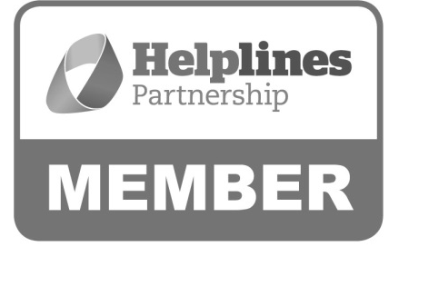
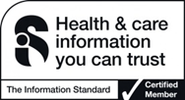

Hartshead House
61-65 Victoria Road
Farnborough
Hampshire
GU14 7PA
01252 749990
enquiries@thebraintumourcharity.org
www.thebraintumourcharity.org
© The Brain Tumour Charity 2015. Registered Charity Number 1150054 (England and Wales) and SC045081 (Scotland).
Version 3.0 (clear print), first produced in standard print format, April 2016. Review date, 2019.

