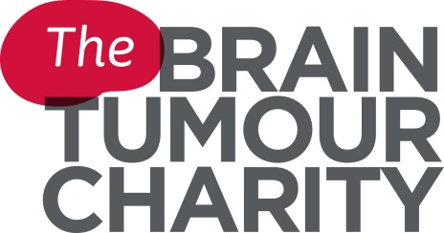

Volunteer Role Description
Cheer Squad – The London Marathon
Why do we need your help?
We need you to help us make as much noise as possible to support our amazing runners with your cheering, shouting and whistling on the side lines of The London Marathon! As a race day supporter you will be invaluable in making the most exciting atmosphere for The Brainy Bunch Runners! You will also be crucial in raising awareness and representing the Charity.
Brain tumours in the UK: the facts
• Brain tumours are the biggest cancer killer of children and adults under 40
• Over 9,365 people are diagnosed with a primary brain tumour each year
• 500 children and teenagers are diagnosed with a brain tumour each year
The Brain Tumour Charity is at the forefront of the fight to defeat brain tumours and is the only national charity making a difference every day to the lives of people with a brain tumour and their families. We fund pioneering research to increase survival, raise awareness of the symptoms and affects of brain tumours and provide support for everyone affected to improve quality of life.
.

What will I be doing?
Cheering for our fantastic team of volunteers at The London Marathon, ensuring that the marathon runner’s race day is one to remember!
What skills/experience do I need?
- A loud cheer!
- Ability to work as a team
- Confidence to interact with the public
- The ability to stand for a long period of time
- Availability on the day of the event: 23 April 2017

How much of my time would you like?
We would like the cheer squad to be at the event from 9.30am (please be aware that this time may change closer to the event)

How will I be trained and supported?
- You will receive a briefing before the event
- You will have a member of staff as a named contact who will support you at the event
- You will be given any equipment necessary to carry out your role

What can I gain from volunteering with you?
- The opportunity to meet new people at fun and inspiring events
- The satisfaction of knowing that you are making a valuable contribution to the lives of those affected by brain tumours
- Utilising your existing skills as well as developing and learning new ones

Where will I be based?
The London Marathon is based all across central London. The location of our cheer point will be detailed in the event briefing.

How do I apply?
Contact the Volunteer Coordinator on 01252 237818
Or email volunteering@thebraintumourcharity.org
Or write to: The Brain Tumour Charity, Hartshead House, 61-65 Victoria Road, Farnborough, GU14 7PA

