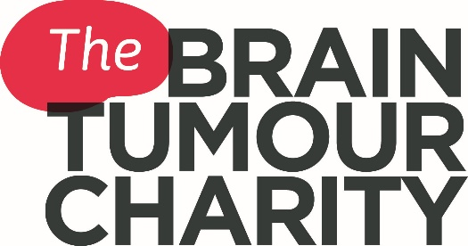

Questions to ask
Talking to your medical team is important - asking questions can help you to understand your condition and allow you to make informed decisions about your treatment and care. You may want to write down a list of questions, or print this list to take with you when you see your medical team.
These questions have been written from the perspective of a patient and are not an exhaustive list. There may be additional questions that you may also want to ask that are important to you. Some questions may be personal and difficult to ask, your medical team will be used to answering these and will be happy to help.
Don't worry if you don't get to ask all of your questions at once, or if you think of further questions, you may be appointed a key worker within your medical who will be your main point of contact. They will be able to help answer the questions you have, or refer you to someone that can help.

Diagnosis
- What type of brain tumour do I have?
- What grade is my brain tumour? And what does this mean?
- What size is my brain tumour?
- Where is my brain tumour located?

Treatments
- What treatments are available to me?
- What are the risks and benefits of these treatments?
- What are the possible side effects of treatment, both long and short term?
- Are there any biomarker tests available to me?
- How often will I have to come to hospital for treatment?
- Is there any transport or help with cost of fares to the hospital?
- When should I start treatment?
- Are there any clinical trials available to me?
- Will any treatments prevent me from being able to take part in a clinical trial in the future?
- What is the likelihood of my tumour reoccurring? If this occurs what treatment options will be available to me?

My healthcare team
- Who are the people that make up my health care team, and what do each of them do?
- Who will be in charge of my overall treatment and follow up care?
- Whom shall I call if I have any questions or problems?
- Can I have a second opinion?

Lifestyle
- How will my brain tumour and treatments affect my daily life? Will I still be able to work, do housework etc?
- Could treatment affect my fertility? If so should I speak to fertility specialist before it begins?
- What support services are available to me and my family?
- Do you have any reading materials that will help me understand my condition, treatments and the support available to me?

After treatment
- Will I be able to return to work?
- After treatment what follow up tests will I need?
- What will happen at my follow up appointments?
- How often will I need to have a scan?
- What should I do if I am worried between my appointments?

